**How to draw Arabic text in .NET PDF library grid cell**

The Syncfusion Essential® PDF is a feature-rich and high performance [**.NET PDF library**](https://www.syncfusion.com/document-processing/pdf-framework/net) used to create, read, and edit PDF documents programmatically without Adobe dependencies. Using this library, you can preserve Arabic text in a PDF table cell using C#.

**Steps to preserve Arabic text properly in a PDF document programmatically:**

1. Create a new console application project.A screenshot of a computer

   AI-generated content may be incorrect.
2. Install the **[Syncfusion.Pdf.Net.Core](https://www.nuget.org/packages/Syncfusion.Pdf.Net.Core" \t "_blank)** NuGet package as a reference to your console application from [**Nuget.org**](https://www.nuget.org/).

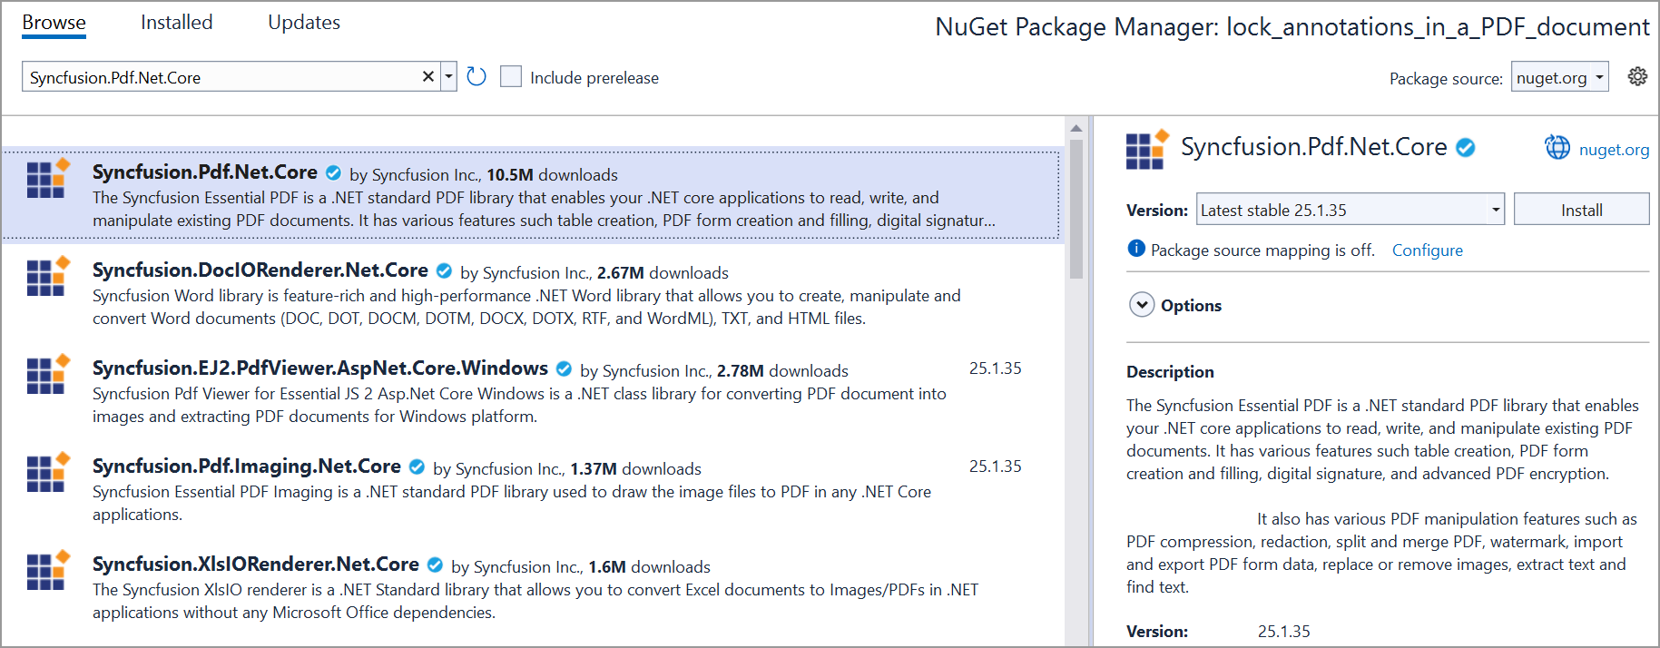

1. Include the following namespaces in the Program.cs file.

**C#**

using **Syncfusion**.Pdf;

using **Syncfusion**.Pdf.Grid;

using **System**.Data;

using **Syncfusion**.Drawing;

using **Syncfusion**.Pdf.Graphics;

1. Use the following code sample in Program.cs to preserve Arabic text properly in a PDF document.

**C#**

//Create a new PDF document.

**PdfDocument** document = **new** **PdfDocument**();

//Add a page.

**PdfPage** page = document.Pages.**Add**();

// Open a file stream.

**FileStream** fontStream = **new** **FileStream**(@"../../../arial.ttf", **FileMode**.Open, **FileAccess**.Read);

// Create a PdfTrueTypeFont object.

**PdfFont** font = **new** **PdfTrueTypeFont**(fontStream, 14);

// Create a PdfStringFormat object for text formatting.

**PdfStringFormat** format = **new** **PdfStringFormat**();

// Enable complex script support for the string format.

format.ComplexScript = true;

//Set right-to-left text direction for RTL text.

format.TextDirection = **PdfTextDirection**.RightToLeft;

//Create a PdfGrid.

**PdfGrid** pdfGrid = **new** **PdfGrid**();

//Create a DataTable.

**DataTable** dataTable = **new** **DataTable**();

//Add columns to the DataTable.

dataTable.Columns.**Add**("ID");

dataTable.Columns.**Add**("Name");

//Add rows to the DataTable.

dataTable.Rows.**Add**(**new** object[] { "E01", "مرحبا" });

dataTable.Rows.**Add**(**new** object[] { "E02", "وداعا" });

pdfGrid.Style.Font = font;

//Assign data source.

pdfGrid.DataSource = dataTable;

**PdfGridCell** cell = pdfGrid.Rows[1].Cells[1];

cell.StringFormat = format;

**PdfGridCell** cell1 = pdfGrid.Rows[0].Cells[1];

cell1.StringFormat = format;

//Draw grid to the page of PDF document.

pdfGrid.**Draw**(page, **new** **PointF**(10, 10));

//Creating the stream object.

**MemoryStream** stream = **new** **MemoryStream**();

//Save the PDF document to stream.

document.**Save**(stream);

// Write the content of the memory stream to an output PDF file.

**File**.**WriteAllBytes**("Output.pdf", stream.**ToArray**());

//Close the document.

document.**Close**(true);

A complete working sample can be downloaded from [**Preserve\_Arabic\_text.zip**](https://support.syncfusion.com/agent/)

By executing the program, you will get the PDF document as follows.

Take a moment to peruse the documentation for [**working with Text**](https://help.syncfusion.com/file-formats/pdf/working-with-text), where you can find the other options like drawing right-to-left text, multicolumn text, consuming TrueType fonts, Standards fonts, and CJK fonts.

Click [**here**](https://www.syncfusion.com/document-processing/pdf-framework/net)to explore the rich set of Syncfusion Essential® PDF features.